Shipping Cost Calculator

**Business Requirement:-**

Build a shipping calculator that given your zip code calculates how much it would take to ship to you

**Functional Specification:-**

### Assumptions

Below assumptions have been made to complete this task.

1. User is required to input Package type, Package Dimensions & Package weight among which weight is mandatory
2. User is required to input source location details i.e., zip code & destination city or Zip Code within USA
3. Limit the no of available carriers to USPS, FedEx, UPS
4. Pre-defined Source zip code & destination zip code mapping. This means from a given source location code, carriers will be able to ship to all locations defined in the mapping data
5. Each of the aforementioned carriers offers two types of services viz., Normal Delivery, Expedited delivery
6. Pre-defined fixed shipping cost per lb from a source location (Zip code) to other locations for each of the aforementioned carriers

### High Level Flow Diagram

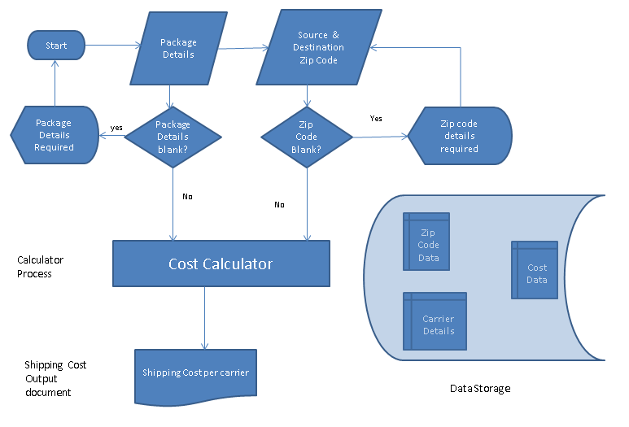

### Solution Description

Step by step description of how shipping calculator works

1. User inputs package details viz., Package type, Dimensions (Length, Width, Height) in inches, Weight in lbs
2. User inputs source & destination location details (Zip Code)
3. Upon click on ‘Calculation’ button, system looks up database to find out if there is a source to destination mapping exists. If yes, it fetches the fixed shipping cost per lb & calculates total shipping cost by multiplying with weight of an item/package
4. System shows total shipping cost for each of the carriers viz., UPS, USPS, FedEx
5. System also shows different services viz., Expedited, Normal delivery & one-day service for each of the carriers

Solution Description

### Technical Overview

**Introduction:-**

This section talks about technical components required to build Shipping Cost calculator. Technical components encompasses Data model, Controllers to control what data to show in UI.

**Data Model Design:-**

Below data objects are needed to design solution for Shipping Calculator

1. Table to store comprehensive list of source/destinations locations with Zip codes
2. Table to store mapping data which signifies a source location that can ship an item to a specific destination location. If a mapping between source location and destination location doesn’t exist, then shipping cost can’t be calculated for the same
3. Table to store list of service types that each carrier provides. Economy Service, Expedited Service & one-day service. Also this table defines list of sub-services under each of the aforementioned service types. USPS Parcel Select Ground, USPS Media Mail, USPS Retail Ground are some of the sub-services
4. A de-normalized table to store minimum shipping cost for a given service type/sub-service b/w source and destination location

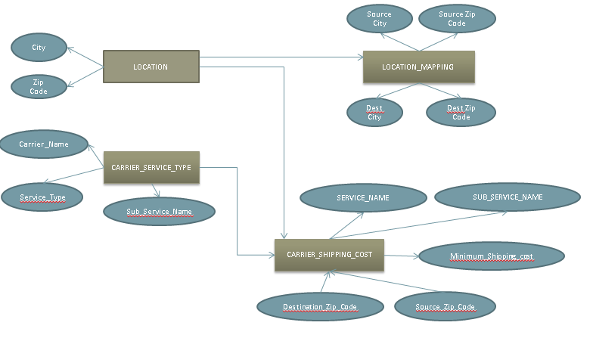

Note: For simplicity, we would just hard-code data values using JSON data format

**Controllers**:-

Java servlet is created to handle Get requests, which fetch /calculates shipping cost summary data from database.

**Servlet GET code snippet:**

This code snippet fetches minimum shipping cost from database and calculate total shipping cost based on the weight of package being delivered. This service converts Java object into JSON format for data exchange with AngularJS

**if**(lane_exist > 0)

{

//location mapping exist.. Go ahead and fetch shipping cost details

PreparedStatement stmt2 = con.prepareStatement("SELECT CARRIER_NAME, CARRIER_SERVICE_TYPE, CARRIER_SERVICE_NAME, SOURCE_ZIP_CODE, DESTINATION_ZIP_CODE, MINIMUM_SHIP_COST + ("+weight+"-1) * 0.25 * MINIMUM_SHIP_COST AS TOT_SHIP_COST FROM CARRIER_SHIPPING_COST WHERE UPPER(CARRIER_NAME)= UPPER('"+carrier_name+"') and SOURCE_ZIP_CODE = '"+ src_zip_code+"' AND (DESTINATION_ZIP_CODE = '"+dest_zip_code+"')");

ResultSet rs1;

rs1 = stmt2.executeQuery();

System.***out***.println("Converting records into Java object");

**while** (rs1.next()) {

rec = **new** ship_cost_summary();

rec.setSummary(rs1.getString("CARRIER_NAME"), rs1.getString("CARRIER_SERVICE_TYPE"), rs1.getString("CARRIER_SERVICE_NAME"),

rs1.getString("SOURCE_ZIP_CODE"),rs1.getString("DESTINATION_ZIP_CODE"), rs1.getDouble("TOT_SHIP_COST"));

json_ship_cost.add(rec);

}

ObjectMapper mapperObj = **new** ObjectMapper();

mapperObj.setVisibility(JsonMethod.***FIELD***, Visibility.***ANY***);

// get Employee object as a json string

String jsonStr = mapperObj.writeValueAsString(json_ship_cost);

System.***out***.println(jsonStr);

response.setContentType("application/json");

response.getWriter().write(jsonStr);

User Interface (view):-

Shipping Details form, which allows user to specify packed item specification for total shipping cost calculation. Input fields required are Weight, Source Zip Code & Destination Zip code. Other fields are optional. Total Shipping cost is based on weight of a package

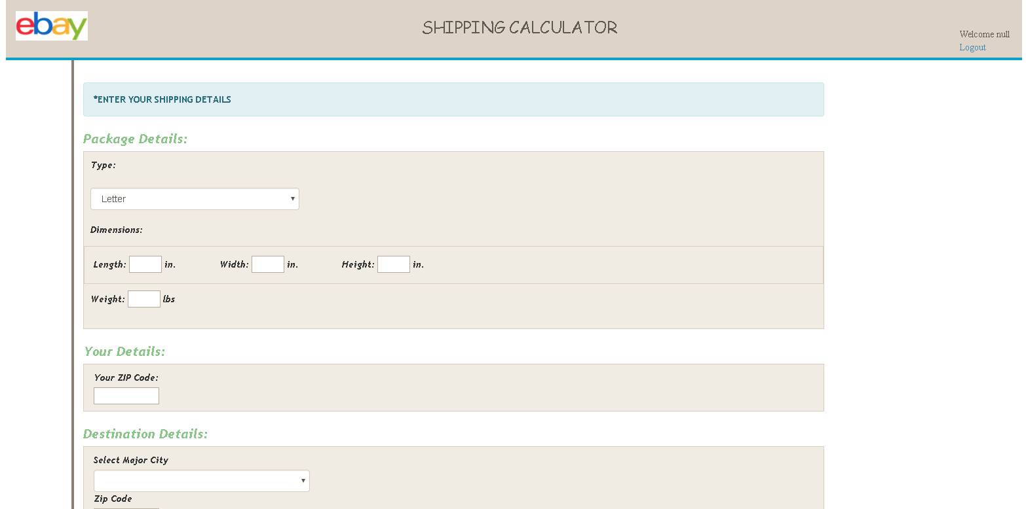

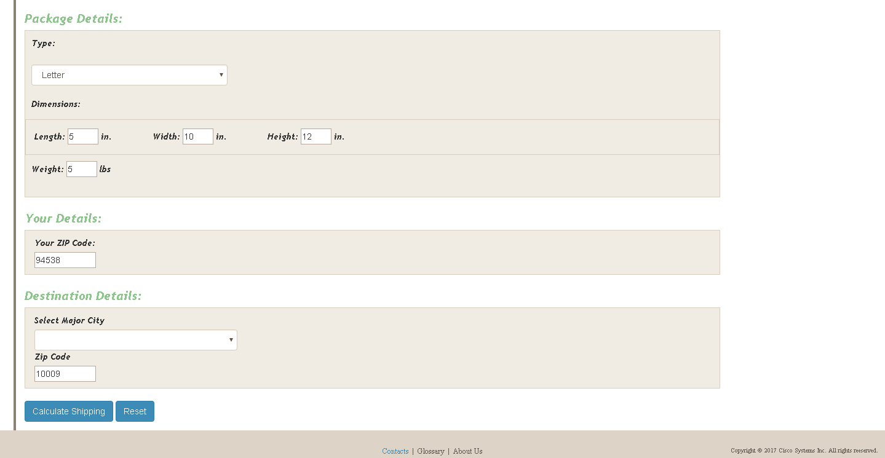

Button ‘Calculate Shipping’ calculates shipping cost based on Weight, Source & Destination Zip codes. Shipping summary results are shown in the below screen

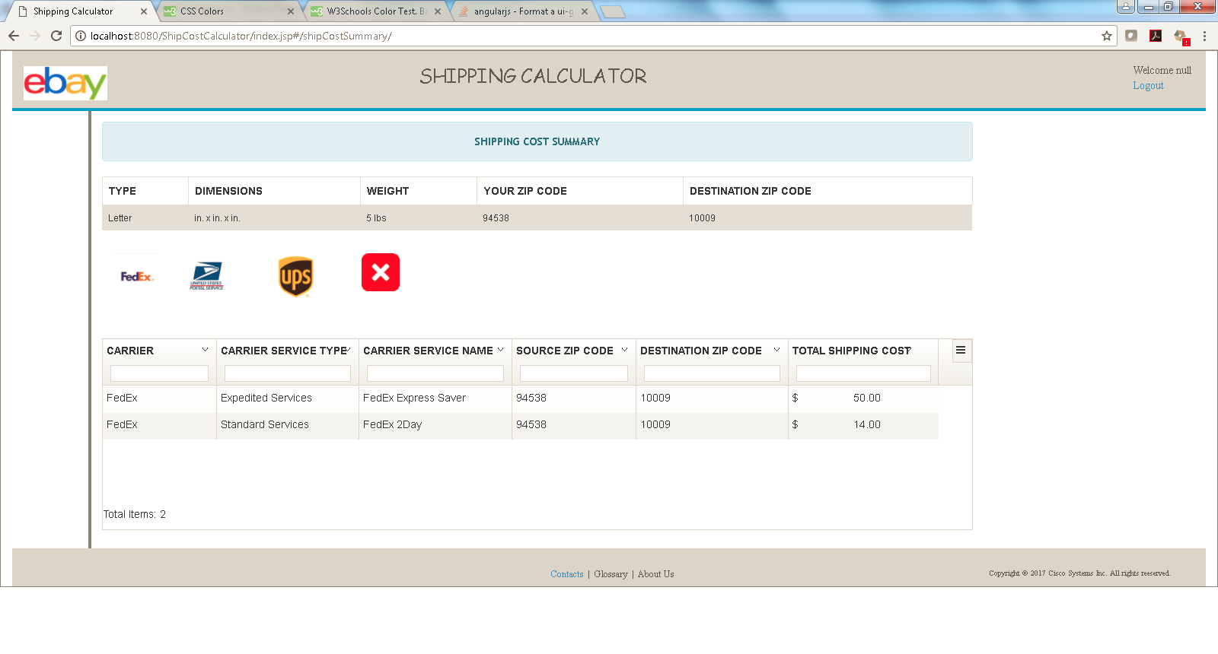

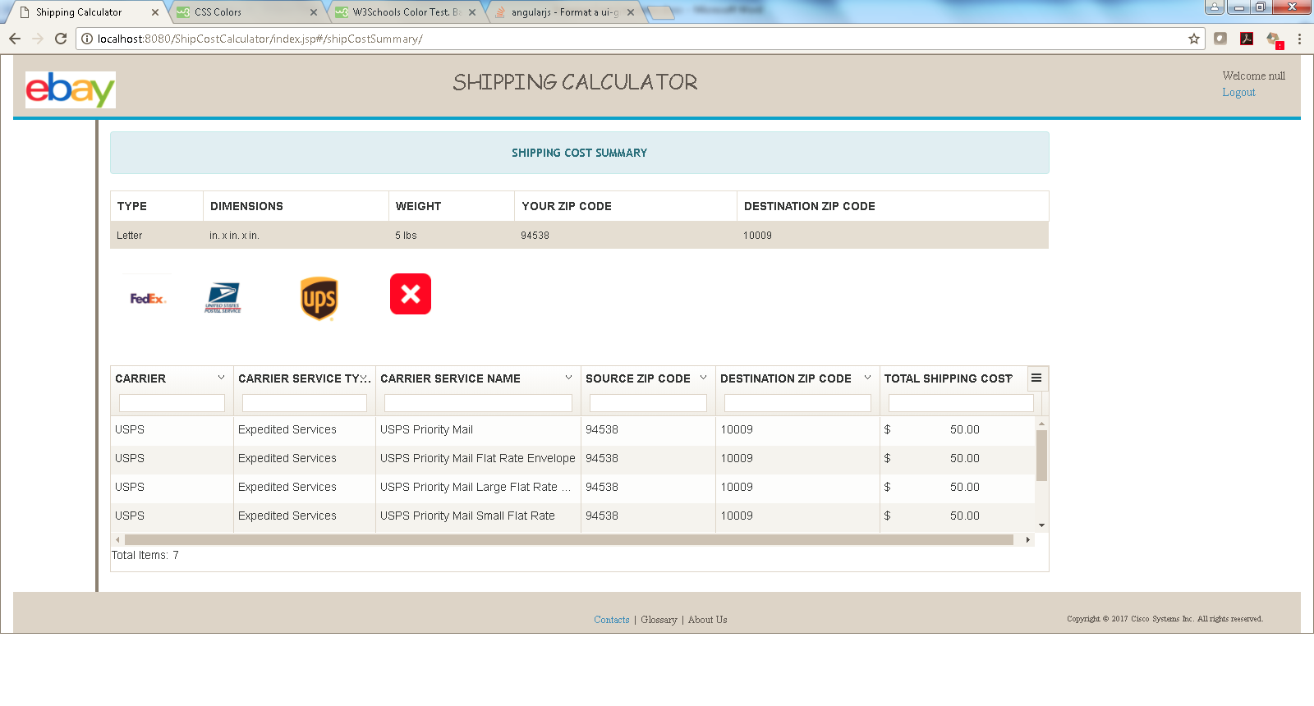

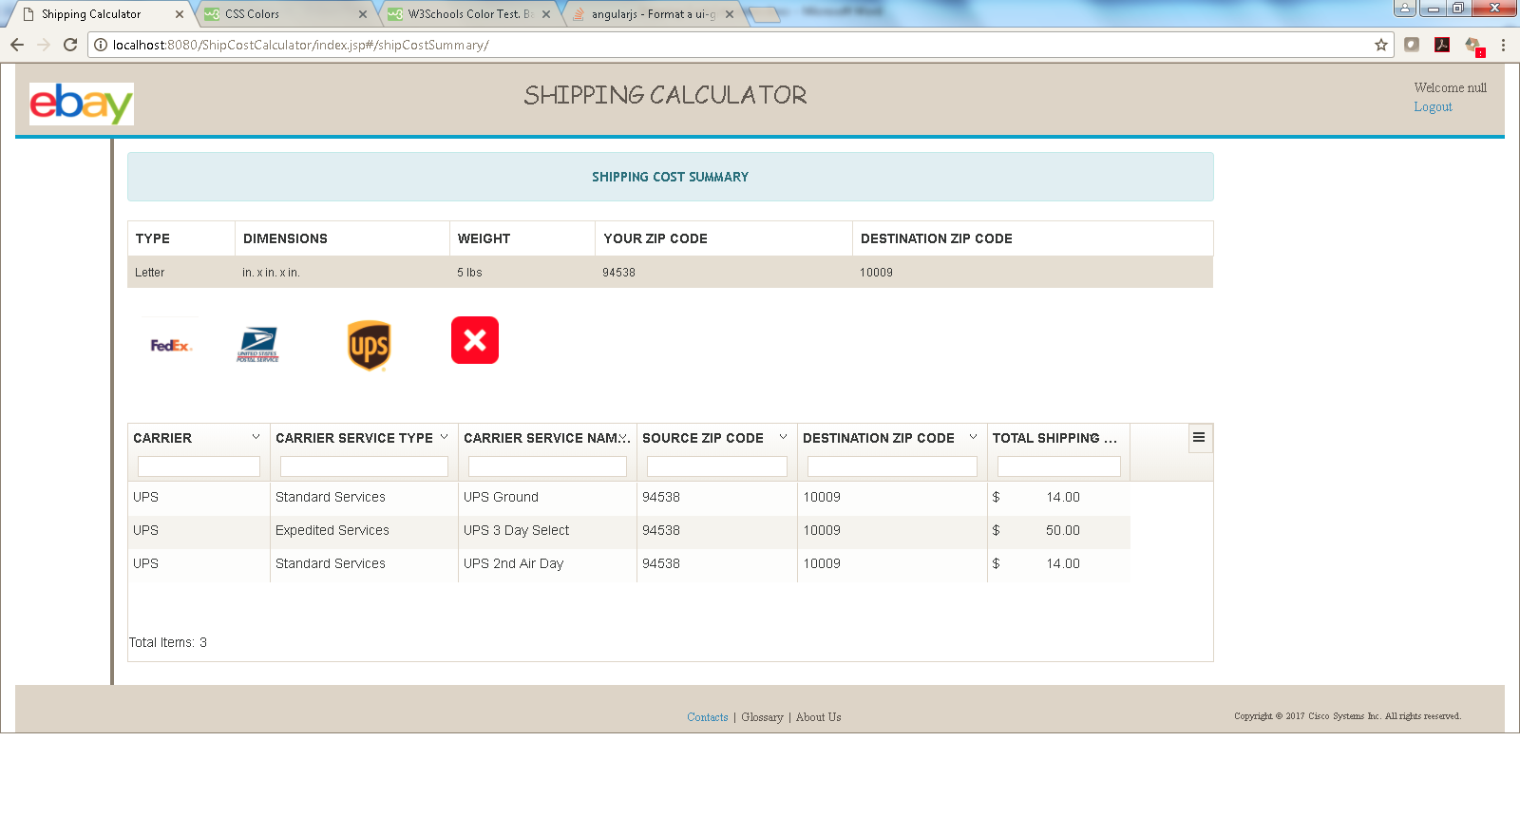

Shipping cost data pertaining to each of the carriers is stored in Oracle database. Data sample used for this project is attached herewith.



Web Project Folder Structure:-

